**1. Which real-world problem have you chosen to work on? Why is it an important problem?**

The issue we are interested in targeting is of child abuse and physical disciplining in Singapore households. The Children and Young Persons Act (CYPA)[1] defines children as people below 14 and young persons as between 14 and 17. Child abuse is defined as “physical abuse, emotional and psychological abuse, sexual abuse, and neglect.” (2023, Family Assist)[2]. However, the actual actions that abuse comprises of are not necessarily clear or agreed upon, legally and socially. In recent years, due to an increase in outreach efforts and public awareness of family violence initiated by the Ministry of Social and Family Development (MSF), there has been a significant rise in reports of child abuse (see figure 1 in appendix)[3]. Caning of children (specifically boys) is still allowed in schools and for reformatory purposes but must follow a set procedure.

Research finds that corporal punishment is not an effective means of disciplining children and in fact, has adverse effects: children may grow up to become more impulsive, susceptible to substance abuse, etc[4]. Singapore’s take on caning and physical disciplining appears to be in tension with its cosmopolitan and developed image.

**2. What will your app do and how will it help solve or mitigate the problem?**

We have chosen to take an educational approach, to provide parents with alternative modes of discipline that would be developmentally appropriate whilst enabling a social support system for parents to lean on. Our app will have two components: the first, outline of the developmental stages, based on Erik Erikson’s Stages Of Psychosocial Development, as an educational resource for parents to anticipate and navigate challenges. The second, a forum for new and experienced parents alike to engage with one another; sharing advice and providing support. Our aim here is to provide comprehensive and easy-to-use access to resources related to raising children which will allow parents a breadth of knowledge and support in one place.

**3. What is the central algorithm or class of algorithms that will enable this app to work? What would the algorithm need to do in your app? What resources have you found explaining the algorithm that you will use?**

* Search Algorithm for Content:
  + Objective: Allow parents to search specific keywords which will lead them to related pages or forum posts
  + Implement a basic keyword-based search algorithm > tokenizing user queries and comparing them to the keywords in the content database.
    - Semantic analysis algorithm:to improve our ability to match content to query eg. if one searches “when to stop wearing diapers” we would somehow link this to a page on say potty training - Word2Vec or BERT ?
* Content Recommendation Algorithm
  + Objective: Recommend pages or forum posts relevant to a specific developmental stage or parenting topic. Could be for pages/forums posts within and outside of app?
  + Using a content-based recommendation algorithm that analyzes the user's preferences and past interactions to suggest relevant content.
* Sorting Algorithm for Forum Posts
  + Objective: Sort forum posts in the order of relevance, popularity, or recency.
  + Options could include sorting by the number of upvotes, recency, or relevance based on user interactions. + Age of child (would be selected by poster)

Additional algorithms:

* User Registration and Authentication
  + Objective: Securely manage user accounts and authentication.
    - Utilize industry-standard authentication algorithms eg. bcrypt
* User Engagement Tracking Algorithm
  + Objective: Track user interactions and engagement to improve content recommendations and forum suggestions
  + Develop a tracking algorithm to record user actions. Analyze this data to refine your recommendation algorithms and make them more accurate.
* Data Privacy and Security Algorithms
  + Objective: Ensure the security and privacy of user data.
  + Encryption algorithms (e.g., AES) to secure sensitive user data.
* Notification Algorithm:
  + Objective: Notify users of new content, responses to their forum posts, or important updates.
    - Implement a notification system that sends notifications to users based on their preferences and activities on the app.

**What are the prerequisites to understand these resources and how easily do you think you will be able to understand them? (e.g. does it require coding ability, some type of math, etc)**

Neither of us have any coding or computing skills and experience, hence this will be a learning process for both of us. Our strengths in this field consist of Hakim’s well-developed knowledge and understanding of psychology which will guide us in finding and applying informational resources to this project.

**4. Under what circumstances do you expect users to use your app? (e.g. will they use it in the**

**office as part of their job, part of their leisure time, will they use it on the move, etc) What is (are) the target demographic(s) for your app? (eg. students, working professionals, young, elderly, etc) What issues, if any, might your users run into while using your app and which you have to keep in mind?**

Our target demographics are parents: prospective, new and experienced. We anticipate that parents would use it in their downtimes, such as commuting to and from work or after the children go to sleep. One problem that could arise would be lack of forum posts when the app first launches. Thus far, there are two remedies we have concocted. The first, we plan to introduce the app to maternity groups to spark engagement and discussion. Secondly, we would enable automated anonymous poll generator based on common challenges a parent would typically encounter. These would help lubricate the process along significantly.

**Appendix**

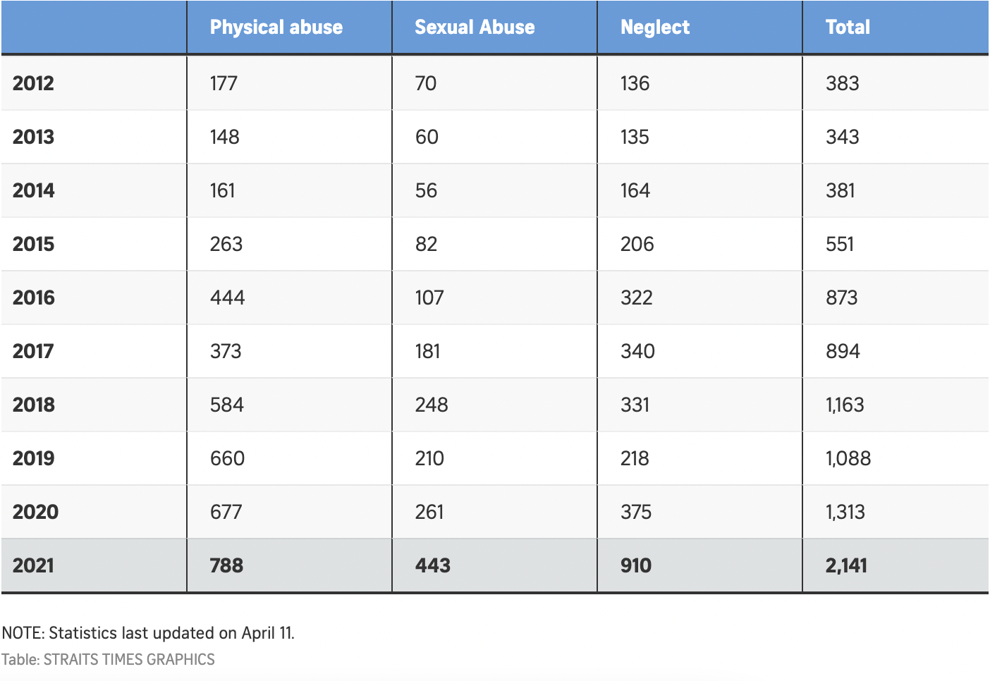

Figure 1

1. <https://sso.agc.gov.sg/Act/CYPA1993>
2. [Family Assist](https://familyassist.msf.gov.sg/content/making-decisions/seeking-safety/understanding-violence-abuse/child-abuse-and-neglect/#:~:text=If%20your%20child%20is%20being,prevent%20or%20stop%20any%20abuse)
3. [Straits Times - 2020 rise in child abuse cases](https://www.straitstimes.com/singapore/child-abuse-cases-in-spore-continue-to-rise-after-hitting-decade-high-in-2020)
4. [Physical punishment of children: lessons from 20 years of research](https://doi.org/10.1503%2Fcmaj.101314)